Explanations for LAD civil applications

- List of civil applications of LAD

- Removal of debris, obstacles and trimming of trees by remote laser burning.
- De-icing of High Voltage Power lines and Communication Towers
- Laser Cleaning, Paint removal, Coating stripping, Dirt removal.

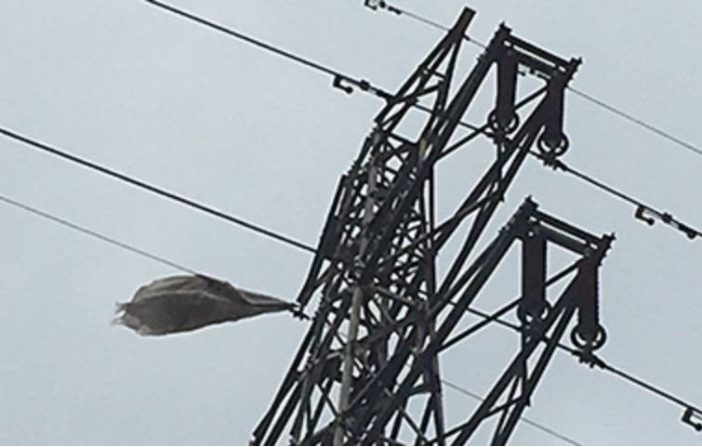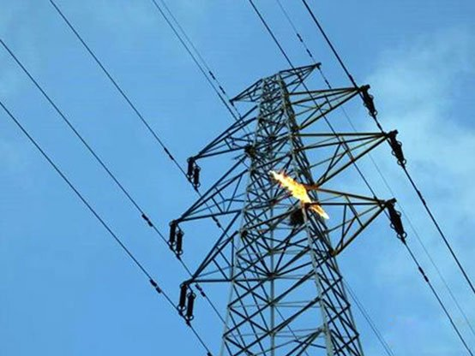
Figure: Removal of debris from high voltage power lines

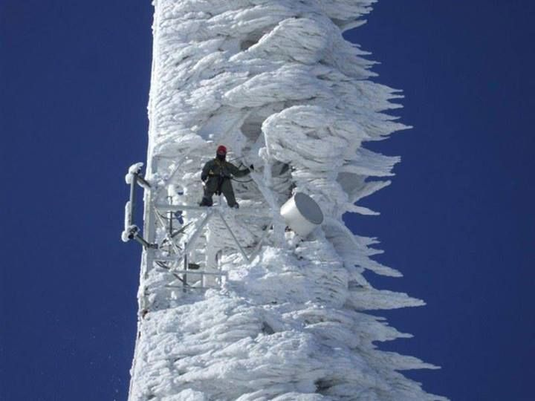
Figure: Removal of ice from frozen communication tower

- Removal / burning of debris, Removal of obstacles and trimming of trees.

LAD civil applications include removal of unwanted objects, debris and obstacles. The LAD cut and burns plastic sheets and debris on high voltage power lines. The laser cuts and burns threes branches in the location of difficult assess.

Normally helicopters are used for performance of these tasks, to protect personal from danger of high voltage, and to get access to the hard to reach locations. Use of lasers from the ground is way less expensive.

Here is a more detailed list of tasks for LAD.

  - Cleaning/burning of foreign objects such as kites, kite strings, fishing line, plastic bags, advertising cloths, transparent plastic film, agricultural film, plastic bags bird nests, honeycomb, branches, etc. on power lines;
  - Laser deicing of power lines and communication towers in winter;
  - Removal of small tree barriers and branches,
  - Remote exclusion of dangerous goods;
  - Remove the hornet's nest and expel dangerous creatures from invading the living area.

Advantages of LAD compared to alternative solutions are following:
- LAD is based on CO2 laser, while alternative solutions are based on fiber laser. LAD operates at LWIR spectral range (~ 10,000nm) while fiber lasers operate in NIR spectral range (~ 1,000nm). Absorptions of plastics, ice and wood are dramatically better at LWIR than absorption at NIR, hence LAD laser is more efficient that fiber lasers for the task
- LWIR spectral range is better than NIR spectral range in terms of laser safety. LAD is less dangerous than fiber lasers
- Laser power of LAD is dramatically higher than laser power of alternative solutions. LAD burns objects faster, it has higher productivity, it removes larger objects.

References on alternative solutions:

Company 1 http://www.removelaser.net/LOR/LHW-Series
Company 2 https://www.demarkchina.cn/laser-cleaning-machine/robot-automated-laser-cleaning/laser-obstacle-removal-equipment.html
Company 3 https://www.piotecglobal.com/products/lbc500-fiber-laser-obstacle-remover/
Company 4 https://dwcnclaser.com/laser-tree-cutting/

- Laser Cleaning, Paint Removal, Coating stripping

Laser cleaning uses the difference in the absorption of laser radiation of a specific wavelength between the substrate and the contaminants, or the temperature difference between the melting and boiling points of the two.

After the pollutants / paints / coatings / dirt absorb the laser energy, they vaporize, vibrate, and instantly expand due to heat, and finally peel off the surface of the substrate to achieve the purpose of cleaning.

The burning is associated with smog formation. It is another reason for the process to be conducted remotely, at relatively long safe distance.

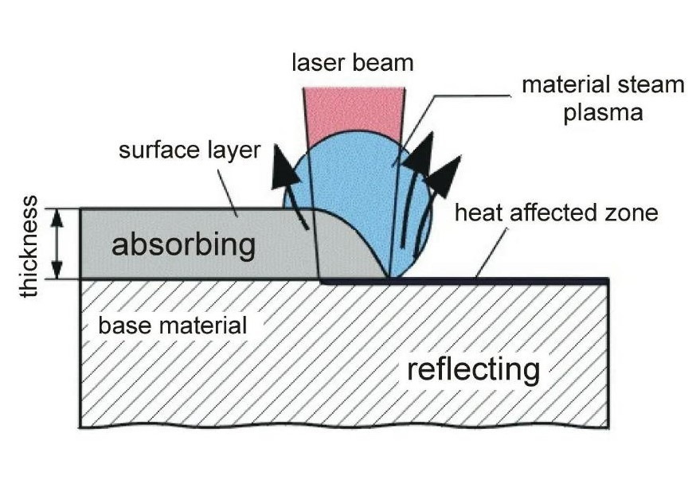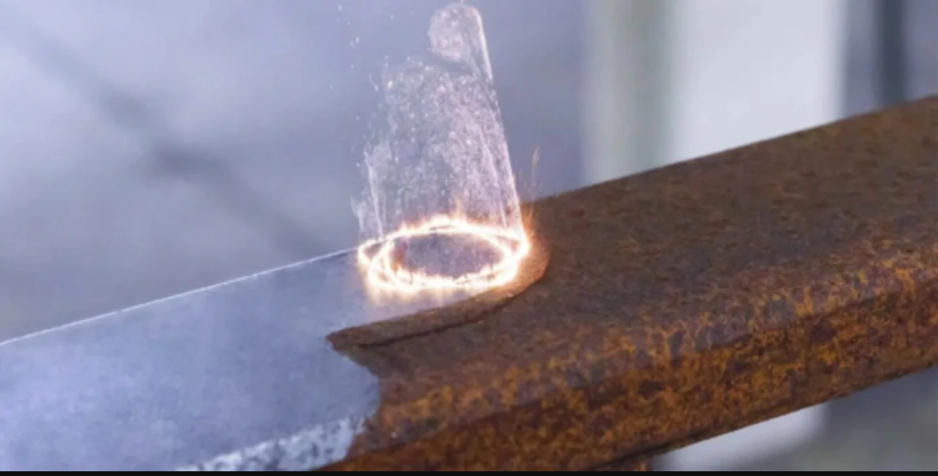

- Market of laser cleaning review

Laser Cleaning Market Size
The global laser cleaning market size was valued at USD 0.66 billion in 2023 and is projected to reach a value of USD 1.15 billion by 2032, registering a CAGR of 6.36% during the forecast period (2024-2032). The increase in laser cleaning market share during the forecast period is related to a growing emphasis on environmental sustainability.
Laser cleaning technology uses laser radiation to remove unwanted substances such as rust, paint, contaminants, and other residues from solid surfaces. This non-contact, non-abrasive, and eco-friendly technique offers high precision and minimal damage to the substrate. As industries globally look for cleaner, more efficient surface cleaning solutions, the market for laser cleaning is experiencing robust growth. Sectors such as automotive, aerospace, manufacturing, and electronics are integrating laser cleaning to enhance processes like welding and coating removal while minimizing environmental impact.
The contamination removal segment owns the largest market share by application.

List of key players in Laser Cleaning Market

- Coherent  - Trumpf Group  - Narran  - Adapt Laser Systems LLC  - Clean Laser Systeme GmbH  - Advanced Laser Technology (ALT)  - Anilox Roll Cleaning Systems  - General Lasertronics  - Laser Photonics  - Laserax | - White Lion Dry Ice & Laser Cleaning Technology  - ARCS-ANILOX ROLL CLEANING SYSTEMS INC.  - P-Laser  - LASCAM  - Andritz Powerlase  - Han's Laser  - Suresh Indu Lasers (SIL)  - SPI LASERS LIMITED  - IPG Photonics Corporation

Reference:
https://straitsresearch.com/report/laser-cleaning-market

General conclusion: Civil market potential of remote laser cleaner / burner type LAD is extremely wide, promising and satisfactory for ARIEL Photonics business.

