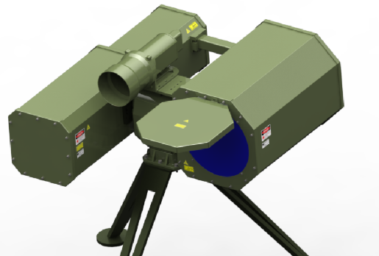**LAD-01 Laser Burner and Remover of Debris**

Eyesafe Laser Burner is a compact 1kW single mode LWIR laser designed for remote burning of debris at hard to access and dangerous locations including cleaning of high voltage lines, high communication antennas, bridges from plastic sheets and wires, and trimming / cutting branches of high trees along railways and likes.

The laser includes a 400 mm diameter reflective telescope, focusing, tracking and steering optics. The laser is accomplished with a compact laser driver and a chiller. The laser is mounted on a precise 2 axis tracking stage for rotation of the laser towards and along the debris.

High power LWIR laser has low absorption in atmosphere, and it is less sensitive to atmosphere turbulence at the long distances. It has good absorption in materials of the targets. As a result, the LWIR laser burner is more effective than a common NIR fiber laser burner. Important factor is that LWIR radiation is significantly less dangerous for eyes compared to NIR fiber laser

The laser burner prototype is live tested to burn plastics sheets, ballons and rubber at distance of up to 1000 meters in conditions of high humidity. That makes it superior to common NIR fiber laser burners.

|  |  |  |  |
| --- | --- | --- | --- |
| **FEATURES**  • Eyesafe at short range of 4km  • Affordable cost. • Cost effective  • Low Maintenance. • Water cooled  • Mobile  • Video and Data Backlog of events  • Withstands field environmental conditions | | APPLICATIONS  Removal of debris and contaminations, cleaning of High Voltage Power Lines and from Antennas.  Remote Trimming of trees and branches in the locations of difficult and dangerous access. | |
| LASER BURNER OF DEBRIS. MAIN PARAMETERS, MODEL: LAS-01-* | | | |
| Laser Burner Type | | Single Mode CW LWIR laser | |
| Laser Burner Power | | 1kW (up to 3 kW optional) | |
| Laser Output Aperture Diameter | | 400mm (500mm optional) | |
| Laser Output Divergence, full angle | | 0.05÷0.08 mrad | |
| Steering mirror diameter, Max Slew and Bandwidth | | < 50mm, <±1 deg, <10Hz | |
| Rotation stage Travel Range Azimuth / Elevation | | 360° (+/-180°) / 60° (+50°/-10°) | |
| Rotation stage Travel Rate / Follow Aim Rate | | 90 / 30 (°/sec) | |
| Rotation stage Pointing error, Bandwidth, Acceleration | | 1mrad / < 2 Hz / 100 º/s² | |
| Laser Burner Eye safety category | | Class 4 IEC 825-1 2001-08 | |
| Laser Safety Distance | | 4 km | |
| Working distance | | 100m to 2000m | |
| Internal Tracking Camera VIS/NIR | | Low Light 2Mpx 30FPS, FOV <5 deg | |
| Warm-up time (min) | | < 2 | |
| Environmental | | -20°C … +50°C | |
| Weight (kg) Optical head / Rotation stage  Power Supply / Chiller | | 80 / 20  60 / 60 | |
| Dimensions (m) Optical head / Rotation stage (WxLxH) Power Supply / Chiller | | 1.5 x 1.5 x 0.5 m3  / 0.25 x 0.25 x 0.5 m3  0.4 x 1 x 0.25 m3 / 1.2 x 1 x 0.8 m3 | |
| Power input | | 3 Phases AC 15kW | |
| **Optional:** | |  | |
| Rangefinder (-LRF) | | Up to 3km, 1pps, Eyesafe | |

Specifications in this document are subject to change without notice.

Part Number examples for ordering:

|  |  |  |
| --- | --- | --- |
| Line | Part Number for ordering | Includes |
| 1 | LAS-01-1kW-400mm | Laser Burner 1kW d400mm, Power Supply and Chiller |
| 2 | -LRF | As lines 1 above, +LRF |

